Mr. President - What Did You Agree to at the G20? Part 2
Education is a core element of implementing Sustainable Development, aka Technocracy. It requires a system of human conditioning on a global scale. Technocrats do not value individual talent and abilities, but only the ability to fit into the larger global good. By Alex Newman
(In reference to the UN Global Education Institute)
Occasionally, I do report on other's articles when they are in line with mine. Recently, I discussed with Alex Newman about his article on the G20 as well as my own. Alex joined me on a radio show a couple of weeks ago and really laid out the UN/UNESCO plan to use our children to support their Sustainable Development lying scheme.
Alex has just published another article on the G20 addressing mostly the aims and plans regarding our children and how they are to be the tools of the Agenda 2030 plans - please read below.
Parents - you need to be on top of your schools and school boards when it comes to their support of the UN/UNESCO Sustainable Development plans. They are using your tax $$ to manipulate this scheme - why should we be paying for the destruction of our own country?
UN Showcases Lessons to Brainwash Children
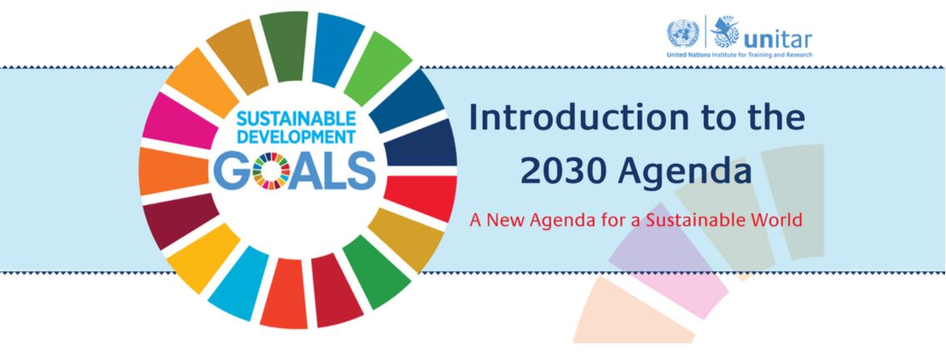
By Alex Newman, published August 31, 2017 Freedom Project.com
The United Nations, often ridiculed as the dictators club, has just released lessons to help indoctrinate people around the world into accepting the UN's so-called “Agenda 2030,” also known as the Sustainable Development Goals or SDGs. While the propaganda targets humanity, the UN acknowledges that it is specifically aimed at youth, described in the SDGs as “critical agents of change.”
The latest UN scheme to brainwash people into supporting its radical agenda for globalism, socialism, and technocracy is a free course dubbed “Introduction to the 2030 Agenda: A New Agenda for a Sustainable World.” According to promotional materials, it is “designed to improve general awareness about the 2030 Agenda and Sustainable Development Goals for policy-makers and the general public, especially youth.”
The course, developed with public money by the UN “Institute for Training and Research” (UNITAR) and the “Global Goals Educator Task Force,” also created other materials aimed at spreading the UN's totalitarian ideology of “sustainable development.” It includes modules dealing with the UN's sanitized version of the origins of the SDGs, “a call for transformative action,” “policy integration and synergies,” the “leveraging of resources” (aka your money), and much more.
The UN has also developed propaganda materials and lesson plans to indoctrinate children as young as kindergarten all the way through 12th grade. “The Task Force is also developing a database of global educators who are responding to a call to action within education to meet the SDGs, and creating a database of open and accessible resources, lesson plans and global projects aligned with the SDGs,” according to Lynn Wagner, the Group Director of “SDG Knowledge” for the tax-funded “International Institute for Sustainable Development.”
Also, being recommended is the development of a “comprehensive curriculum of high quality lessons/resources for student's grades K-12,” the IISD said. It called for a “professional development program” to help brainwash teachers and educators so they can “bring the SDGs into their instruction” and brainwash their impressionable young students.
And finally, the UN System Staff College (UNSSC) is offering and promoting what is touted as “a foundational course on the 2030 Agenda for Sustainable Development.” Other UN tentacles are developing and delivering “a series of activities, e-learning courses, face-to-face workshops, webinars, learning sessions/conferences etc.” “This Agenda will require all countries and stakeholders to work together to implement the global goals at national, regional and global levels,” it says.
A key goal of all the propaganda and indoctrination being pumped out by the UN under the guise of “education” is “mainstreaming” the Agenda 2030. That will presumably take some serious effort, though, considering the extreme ideology being promoted—an ideology completely at odds with liberty and Judeo-Christian values.
Far from being harmless, the UN Agenda 2030 being touted in these “courses” is essentially a road map to global socialism and technocracy. The mass-murdering Communist Chinese dictatorship boasts that it played a “crucial role” in developing the scheme, which top UN leaders have referred to as a “masterplan for humanity” and a “Declaration of Interdependence.” The plan calls for national and international wealth redistribution, government control over consumption and production, more centralized power at the global level, and more.
And ironically, the UN itself has made clear that real education threatens its radical agenda. “Generally, more highly educated people, who have higher incomes, consume more resources than poorly educated people, who tend to have lower incomes,” explains a UN “toolkit” for global “sustainable” education, which is still posted online at UNESCO's website. “In this case, more education increases the threat to sustainability.”
The UN brags that it is coming for your kids. In fact, in Agenda 2030, the UN specifically says that “all” children must learn not just to accept or tolerate this totalitarian ideology known as “sustainable development,” but to promote it. Fortunately, the U.S. Senate has not ratified Agenda 2030. It is time for policymakers in the United States to protect the American people from this insanity. Link
Note from Diane: I feel I need to remind you that our education system, especially since the presidency of Obama, has been focused not on learning intelligently, but learning to endorse social issues which align with immorality and lack of respect for anyone or anything.
As Dr. Duke Pesta stated, " Amid the rapid creep of social justice education—kudzu vines of progressive craziness have included the sexualization of preschoolers, the trans-gendering of elementary schoolers, the shaming of white and Christian middle schoolers, and the coopting of science in the name of global warming for high schoolers-one topic will dominate all discussions this year: Trump."
Yes, liberal teachers went nuts and introduced your children to sing songs of praise and worship of the mere man Obama, but watch to see the same liberal ideology change their focus to diminishing and attacking conservative President Trump - all in alignment to teaching your children to always be angry and unhappy about whatever their government puts forth.
One teacher recently put Trump's picture on a bulletin board titled "Historical Bullies" with Hitler, bin Laden, Stalin, Kim Jong-un, and Sadam Hussein. When parents complained, the school "pooh-poohed" the whole thing to mostly "let's move on." Now apparently it is acceptable to diminish mass murders to "common bullies". Is that what is out on our streets?
Not that our government gets an A+, but it is the allegiance to our country which is being diminished by not teaching the truth and that is the whole issue - diminishing the truth about everything. And yes, I am upset with Trump's appointment of DeVos because I know her agenda, but that doesn't make him a bully - just ill informed!
Why aren't our History books teaching the good things about General Lee? The schools accept these erroneous books spreading lies. General Lee was against slavery, yet he was a Confederate officer. That's because contrary to what they are teaching our children the Civil War was not about slavery - it was about "state's rights" - the southern states were demanding them and the northern dominated Congress wasn't giving it to them.
The Congress at that time heavily favored the industrialized northern states to the point of demanding that all the South sell was cotton and other raw materials only to the factories in the north, rather than to other countries. The Congress also taxed the finished materials that the northern industries produced heavily, making finished products that the South wanted, unaffordable. The Civil War should not have occurred. If the Northern States and their representatives in Congress had only listened to the problems of the South, and stopped these practices that were almost like the "taxation without representation" of Great Britain, then the Southern states would not have seceded and the war would not have occurred.
And many choose to forget at the time of the Civil War the Republican Party was LIBERAL!
Most students today are not taught that the greater number of slaves during the Civil War were in the NORTH - not the SOUTH! Well, if we tell them the truth now they might even be able to make things right! Restore the Original 13th Amendment!
Andrew Jackson was a good man and against the war. He was also against the Northern bankers and the NATIONAL banks. The corrupt deal in 1824 to assure John Quincy Adams was elected President rather than Jackson also lead to the split of the Democratic-Republican party. The 1828 election of Jackson was seen as the election of the "Common Man" with Jackson taking 54% of the vote.
In trying to protect the country he vetoed as president the re-chartering of the Second Bank of the United States and they tried to assassinate him for it. He didn't believe it was constitutional and that it favored the rich over the "common man" - it did and still does. He removed government money from the bank and put it in State banks. His stand on the banking system created a large battle between Jackson and the Rothschild Banking Cartel.
Did you know the very idea of a central bank by "professional" bankers had been a contentious issue since the founding of the United States? So, who continues to support the banking system which controls this country along with others through their "Shadow Government"?
America - between the liars and deceivers within our government and the powers of which have been given to the UN - are you going to stand by and allow them to DESTROY OUR COUNTRY?
History tidbit - the Bank of North America created in 1781 lasted 3 years due to what - rampant fraud and corruption!

